**CEE 526 Finite Elements for Engineers**

**Modeling Project 1-2**

Due Date: Mar.25th , 2016

Author: Michael Justice

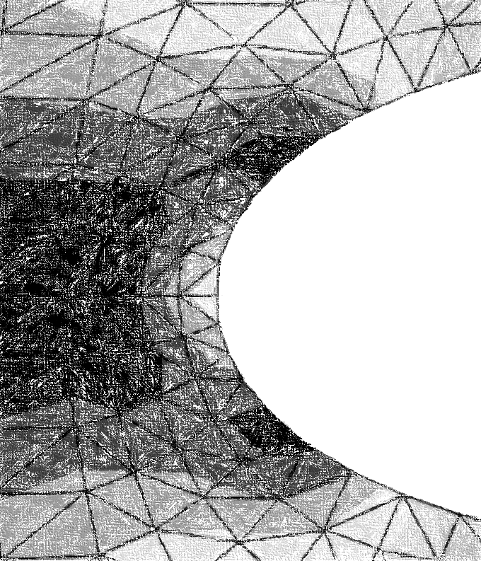

Table of Contents

Torque Arm 4

Problem Description 4

Finite Element Model 5

Results (and Convergence Results) 5

Conclusions 9

References 10

Steel Body 11

Problem Description 11

Finite Element Model 12

Results (and Convergence Results) 12

Conclusions 16

References 17

List of Figures

Figure 1 – (TorqueArm) Problem Figure 4

Figure 2 - (TorqueArm) Model with Shown Boundary Conditions 5

Figure 3a – (TorqueArm) Deformed Shape Using Q4 Elements 6

Figure 3b - (TorqueArm) Deformed Shape Using T3 Elements 7

Figure 4 – (TorqueArm) Stress Convergence of Q4, T3 Elements 8

Figure 5 - (TorqueArm) Displacement Convergence of Q4, T3 Elements 9

Figure 6 - (SteelBody) Problem Figure 11

Figure 7- (SteelBody) Model with Shown Boundary Conditions 12

Figure 8a – (SteelBody) Deformed Shape Using Q4 Elements 13

Figure 8b -(SteelBody) Deformed Shape Using T3 Elements 14

Figure 9– (SteelBody) Stress Convergence of Q4, T3 Elements 15

Figure 10 -– (SteelBody) Displacement Convergence of Q4, T3 Elements 16

List of Equations

**No table of figures entries found.**

List of Tables

Table 1 – (Torque Arm) Q4 Mesh Summary 7

Table 2– (TorqueArm) T3 Mesh Summary 8

Table 3 - (SteelBody) Q4 Mesh Summary 14

Table 4-(SteelBody) T3 Mesh Summary 15

# Torque Arm

## Problem Description

For this FEA (Finite Element Analysis) project, the goal was to a) determine the maximum von Mises stress in a steel torque arm with a perfect circular hole in the center, and b) determine the maximum displacement. These two tasks were accomplished using the FEA program Abaqus. The free (student) version of the program was used for this project. Figure 1 below is a sketch of the steel torque arm.

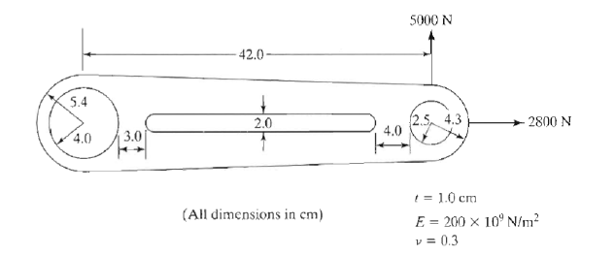

X +

Y+

|  |
| --- |
| Figure 1 – (TorqueArm) Problem Figure |

The model is a torque arm with an overall dimension of approximately 52 cm, with an applied vertical and horizontal load of 5000 N and 2800 N, respectively. The torque arm has an ellipse-shaped hole along the centroidal axis. The elastic modulus of the steel is 200e9 N/m^2 with a Poisson’s ratio of 0.3.

## Finite Element Model

The finite element model (FEM) was constructed using the student version of Abaqus. The limitation of the student version is that all models are limited to 1000 nodes or less. Therefore, only *linear* Q4 and T3 elements were used to stay under the 1000 node limit. These two element types alone were also chosen to ensure a proper systematic approach to yield an accurate result for the convergence analysis.

The model was created on the basis that the torque arm has an elastic (linear), isotropic material with an elastic modulus and Poisson’s ratio as shown in Figure 1. The model was assumed to be of plane-stress, since the thickness of the torque arm is comparatively small to the width and height, and that the loading is only in the X-Y Plane. Because of the assumption of plane stress, there is no shear stress in the X-Z or Y-Z plane (and consequently no strain in those planes either). Since there is no applied loading in the Z-direction (which constitutes the application of plane-stress), there is no strain in the Z-direction.

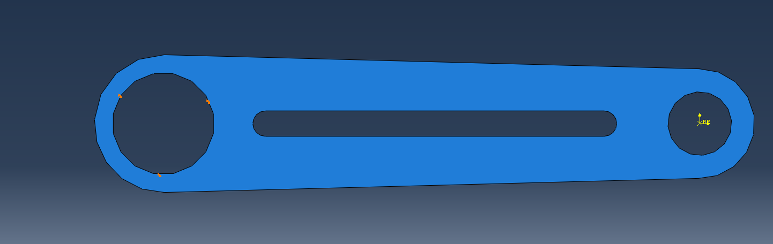

**Pinned Condition**

Figure 2 - (TorqueArm) Model with Shown Boundary Conditions

The loading was applied at the reference point located at the center of the right-hand circle. The boundary (or fixity) conditions were such that the torque arm was pinned in the X-Y directions around the perimeter of the left-hand circle, as shown above in Figure 2.

## Results (and Convergence Results)

Applying the torque, the following deformed shape was generated (Figure 3).

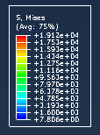`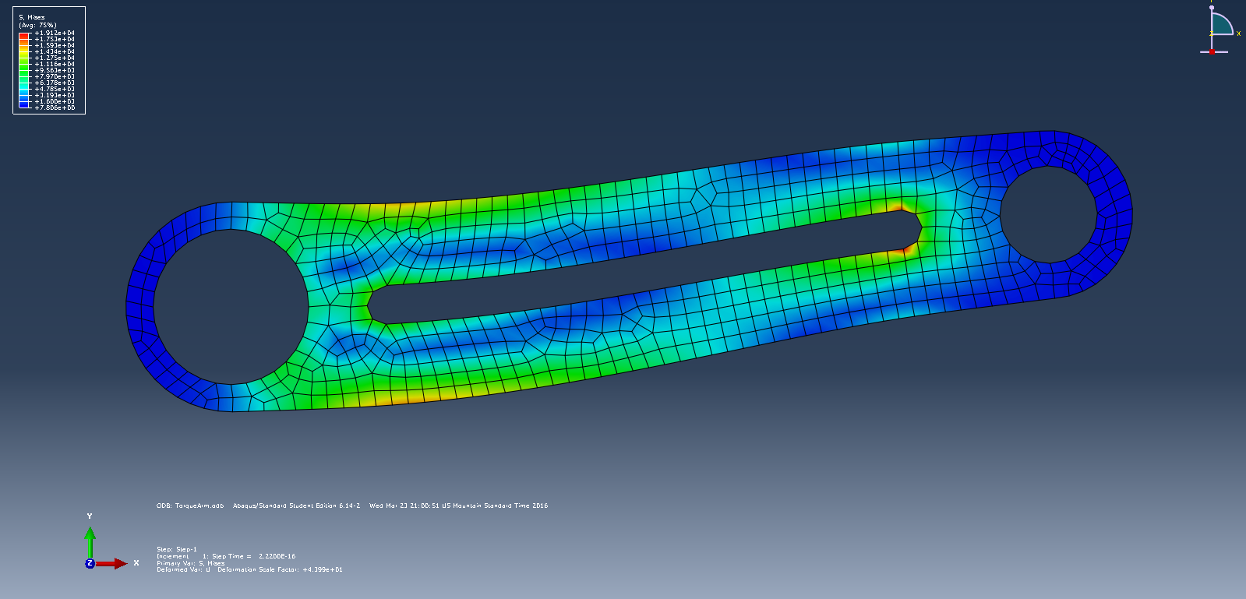

|  |
| --- |
| Figure 3a – (TorqueArm) Deformed Shape Using Q4 Elements |

Note that higher von Mises stresses were encountered at the ellipse-shaped cut-out, and at the edges of the torque arm near the left-hand circle. The following figure (Figure 3b) illustrates the deformed shape of the torque arm with T3 elements.

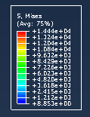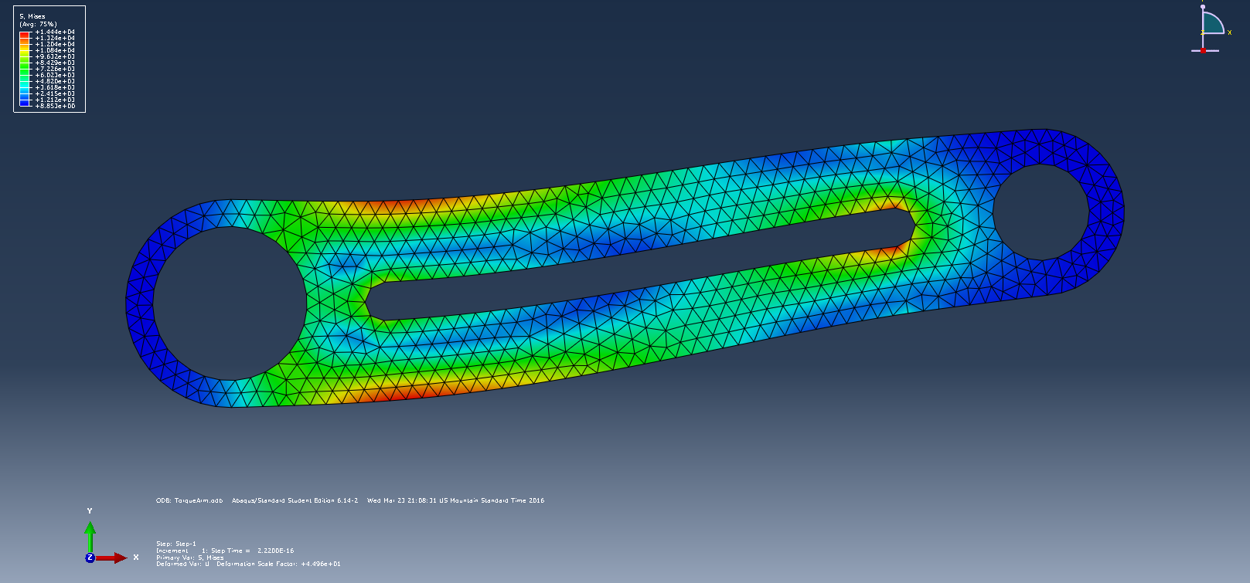

**Bottom Edge**

|  |
| --- |
|  |

Figure 3b - (TorqueArm) Deformed Shape Using T3 Elements

The stress table to the left of Figure 3a, 3b is the von Mises stress color legend for the model. Below is Table 1, which summarizes the finite element result for the Q4 model.

Table 1 – (Torque Arm) Q4 Mesh Summary

|  |  |  |  |  |
| --- | --- | --- | --- | --- |
| **Model** | **Element Type** | **Number of Elements** | **Max Von Mises Stress (KPa)** | **Max Displacement (cm)** |
| Model 1 | Q4 | 15 | 61533 | 0.0464 |
| Model 2 | Q4 | 32 | 68222 | 0.0677 |
| Model 3 | Q4 | 61 | 130000 | 0.0928 |
| Model 4 | Q4 | 410 | 134200 | 0.1167 |
| Model 5 | Q4 | 824 | 143600 | 0.1176 |

From Table 1, it can be seen that the von Mises stress converges from below, which is expected. Below is Table 2, which summarizes the finite element result for the T3 model.

Table 2– (TorqueArm) T3 Mesh Summary

|  |  |  |  |  |
| --- | --- | --- | --- | --- |
| **Model** | **Element Type** | **Number of Elements** | **Max Von Mises Stress (KPa)** | **Max Displacement (cm)** |
| Model 1 | T3 | 31 | 72660 | 0.0364 |
| Model 2 | T3 | 64 | 74530 | 0.0581 |
| Model 3 | T3 | 122 | 126400 | 0.0838 |
| Model 4 | T3 | 820 | 157800 | 0.1132 |
| Model 5 | T3 | 1647 | 163000 | 0.1165 |

From Table 2, it can again be seen that the von Mises stress converges from below. Figure 4 below illustrates this convergence and compares the two element types.

|  |
| --- |
| Figure 4 – (TorqueArm) Stress Convergence of Q4, T3 Elements |

From Figure 4, it can be seen that T3 elements converge faster than Q4 elements, due to the fact that a model with the T3 element type will have twice as many elements than that of the same model with the Q4 element type. Plotting displacements, it can be seen that displacements generally converge faster than stresses. This is because stresses are derivatives of displacements, and therefore error will compound. Figure 5 illustrates the converging trend of the max displacements in the torque arm.

Figure 5 - (TorqueArm) Displacement Convergence of Q4, T3 Elements

## Conclusions

The following observations from the above results can be made about the finite element analysis of the torque arm:

1. T3 elements converge faster than Q4 elements, or in other words, higher-order elements converge faster than lower-order elements.
2. Stresses converge from below.
3. The maximum von Mises Stress was located at the edges of the torque arm at the bending point near the left-hand circle. Stress concentrations were found at the perimeter of the ellipse-shaped cutout.
4. Displacements converge faster than stresses.
5. Maximum von Mises Stress: 163,000 KPa
6. Maximum displacement: 0.1176 cm

## References

# Steel Body

## Problem Description

For this FEA (Finite Element Analysis) project, the goal was to a) determine the maximum von Mises stress in the steel body, and b) determine the maximum displacement on the surface. These two tasks were accomplished using the FEA program Abaqus. The free (student) version of the program was used for this project. Figure 6 below is a sketch of the steel body.

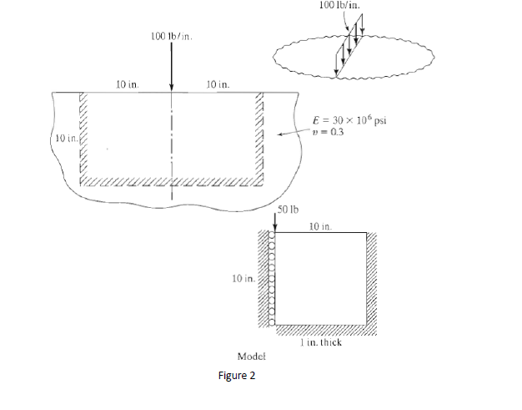

X +

Y+

|  |
| --- |
|  |

Figure 6 - (SteelBody) Problem Figure

The model is a steel body with a cross-sectional dimension of 20”x10” with an infinitely long thickness, and has an applied vertical line load of 100 lb/in. The elastic modulus of the steel is 30e6 psi with a Poisson’s ratio of 0.3.

## Finite Element Model

The finite element model (FEM) was constructed using the student version of Abaqus. The limitation of the student version is that all models are limited to 1000 nodes or less. Therefore, only *linear* Q4 and T3 elements were used to stay under the 1000 node limit. These two element types alone were also chosen to ensure a proper systematic approach to yield an accurate result for the convergence analysis.

The model was created on the basis that the steel body has an elastic (linear), isotropic material with an elastic modulus and Poisson’s ratio as shown in Figure 6. The model was assumed to be of plane-strain, since the thickness of the steel body is infinitely longer than the width and height, and that the loading is only in the X-Y Plane. Because of the assumption of plane strain, there is no shear strain in the X-Z or Y-Z plane. Since there is no applied loading in the Z-direction (which constitutes the application of plane-strain), there is no strain in the Z-direction. In order to simplify the model, half of the steel body was used in the analysis (symmetry). Figure 7 below illustrates the loading and fixity conditions of the model.

`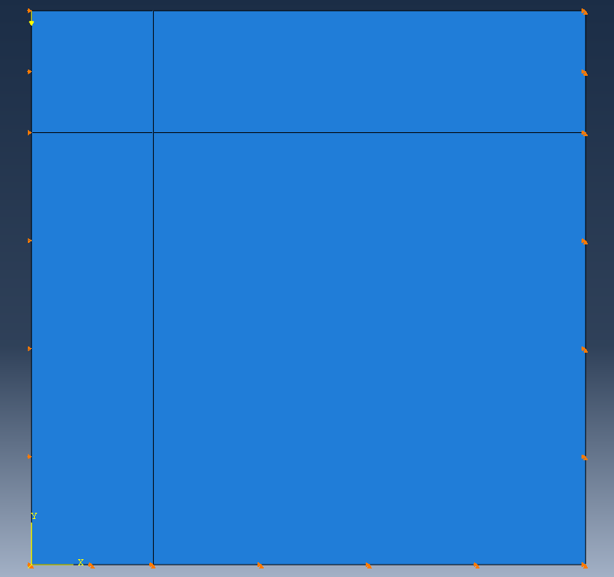

**Pinned Condition**

**Roller Condition**

Figure 7- (SteelBody) Model with Shown Boundary Conditions

The loading was applied at the top-left corner of the body. The boundary (or fixity) conditions were such that the steel body was pinned in the X-Y directions at the right and bottom edges, and fixed only in the longitudinal direction on the left edge (see Figure 7).

## Results (and Convergence Results)

Applying the downward load of 50 lbs at the top-left corner, the following deformed shape was generated (Figure 8a).

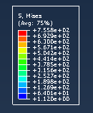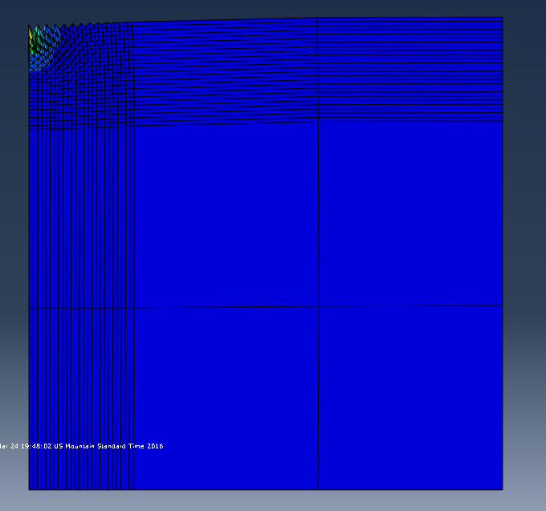

|  |
| --- |
|  |

Figure 8a – (SteelBody) Deformed Shape Using Q4 Elements

The following figure (Figure 8b) illustrates the deformed shape of the steel body with T3 elements.

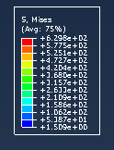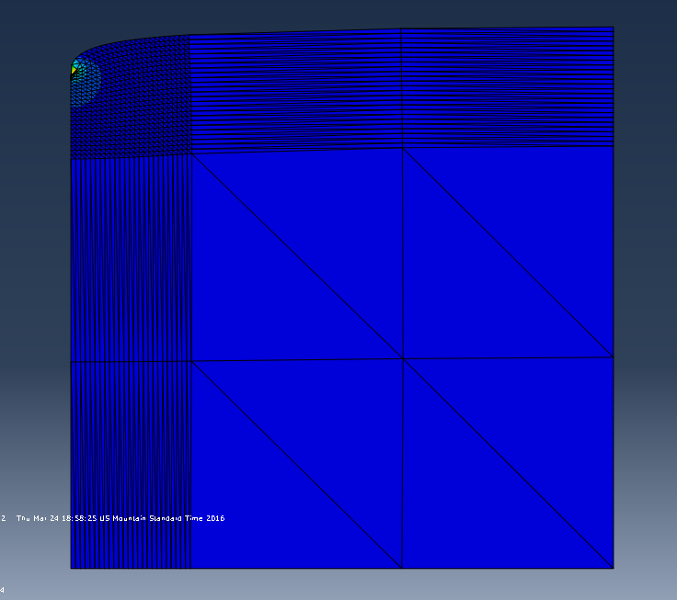

**Bottom Edge**

|  |
| --- |
|  |

Figure 8b -(SteelBody) Deformed Shape Using T3 Elements

The stress table to the left of Figure 8a, 8b is the von Mises stress color legend for the model. Below is Table 3, which summarizes the finite element result for the Q4 model.

Table 3 - (SteelBody) Q4 Mesh Summary

|  |  |  |  |  |
| --- | --- | --- | --- | --- |
| **Model** | **Element Type** | **Number of Elements** | **Max Von Mises Stress (psi)** | **Max Displacement (in)** |
| Model 1 | Q4 | 49 | 152.5 | 0.000013 |
| Model 2 | Q4 | 144 | 303.4 | 0.000015 |
| Model 3 | Q4 | 289 | 454.1 | 0.000016 |
| Model 4 | Q4 | 484 | 605.0 | 0.000017 |
| Model 5 | Q4 | 729 | 755.8 | 0.000018 |

From Table 3, it can be seen that the von Mises stress do not converge, which was not expected. This can be attributed to the downward load condition being applied at the exact location of a boundary condition. This will therefore induce stress singularity within the system, causing the stresses to not converge. Below is Table 4, which summarizes the finite element result for the T3 model.

Table 4-(SteelBody) T3 Mesh Summary

|  |  |  |  |  |
| --- | --- | --- | --- | --- |
| **Model** | **Element Type** | **Number of Elements** | **Max Von Mises Stress (psi)** | **Max Displacement (in)** |
| Model 1 | T3 | 98 | 128.2 | 0.000008 |
| Model 2 | T3 | 288 | 254.2 | 0.000009 |
| Model 3 | T3 | 578 | 379.5 | 0.000010 |
| Model 4 | T3 | 968 | 504.7 | 0.000010 |
| Model 5 | T3 | 1458 | 629.8 | 0.000011 |

From Table 4, it can again be seen that the von Mises stress does not converge. It is also worth noting that the displacements for the higher-order element (T3) are a whole magnitude less than the displacements for the Q4 elements. Figure 9 below illustrates this non-convergence and compares the two element types.

Figure 9– (SteelBody) Stress Convergence of Q4, T3 Elements

|  |
| --- |
|  |

From Figure 9, it can be seen that neither elements converge. Again, this is due to the stress singularity symptom of the model. Figure 10 illustrates the non-converging trend of the max displacements in the steel body.

Figure 10 -– (SteelBody) Displacement Convergence of Q4, T3 Elements

## Conclusions

The following observations from the above results can be made about the finite element analysis of the steel body:

1. Stress singularity will occur if loads are placed at the exact location of a boundary condition.
2. Displacements (and therefore stresses) will vary largely between elements when stress singularity is present.
3. Displacements (and therefore stresses) will not converge if stress singularity is present.
4. Maximum von Mises Stress: 755.8 psi
5. Maximum displacement: 1.1e-5 in

## References